Smart Security Using Biometrics and Cloud Computing

Drake Csage
Electrical Engineering Student
Central Michigan University
Mount Pleasant, Michigan
csage1da@cmich.edu
Benjamin Strandskov
Electrical Engineering Student
Central Michigan University
Mount Pleasant, Michigan
stran1b@cmich.edu
Niall Mulcahy
IoT Applied Computing Student
Waterford Institute of Technology
Waterford, Ireland
niallmul97@gmail.com
Laurie Fitzek
Iot Applied Computing Student
Waterford Institute of Technology
Waterford, Ireland
lauriefitz98@outlook.ie
Dr. Kumar Yelamarthi
Professor of Electrical and Computer Engineering
Central Michigan University
Mount Pleasant, Michigan
yelam1k@cmich.edu

Abstract— IoT is an electrical and computer engineering field that is growing rapidly. Unfortunately, the automotive industry is always a step behind when it comes to security. With the ability to rent out your car, smart toll systems on the rise, and more people utilizing the digital wallets, the smart security system opens up a very broad range of what this can optimize and make easier for the automotive customer, all while securing the customer’s vehicle(s). The idea behind the smart security system is to use facial recognition not only to secure the vehicle, but to preload the user settings as well. The smart security system offers a valid form of security to the car, the availability to offer safer driving techniques, and preload the user’s settings of the vehicle.
Keywords—IoT, Facial Recognition, PostgreSQL, Security

Introduction
With the growing field of IoT, security is a topic that is often overlooked. Simple to more complex topics include hackers’ ability to signal crack a key fob using an RF attack, to controlling a network and shutting down a manufacturing plant. Simpler enough, another topic that is often overlooked in security is simply unlocking a car. Security professionals try their best to keep the networks secure, but often are misled by the simpler topics: unlocking and stealing items inside a car.
Biometric facial recognition is a topic that can increase the security of a car. With the internet of things, we can utilize unlocking a car with biometrics. The camera connected to the Raspberry Pi 3 will image process the person trying to unlock the car by sending the information over the PostGreSQL database. The database will compute the information and give a yes or no to unlocking the car. If “Yes,” the car will unlock and optimize the person’s car settings. These settings will include but are not limited to: seat position, Apple Music or Spotify accounts, mirror position(s), the Apple Wallet, unlocking or locking the glove box, and utilizing phone as a key (upcoming application used in the automotive industry). Connecting the music accounts will allow the driver to have music playlists available, the digital wallets enable easier access to smart toll systems, and phone as a key makes it easier to transfer rights to a person and enable them to drive a vehicle for a period of time. If “No,” the camera will take a screenshot of whomever is attempting to unlock the vehicle and send a screenshot to the owner of the vehicle.
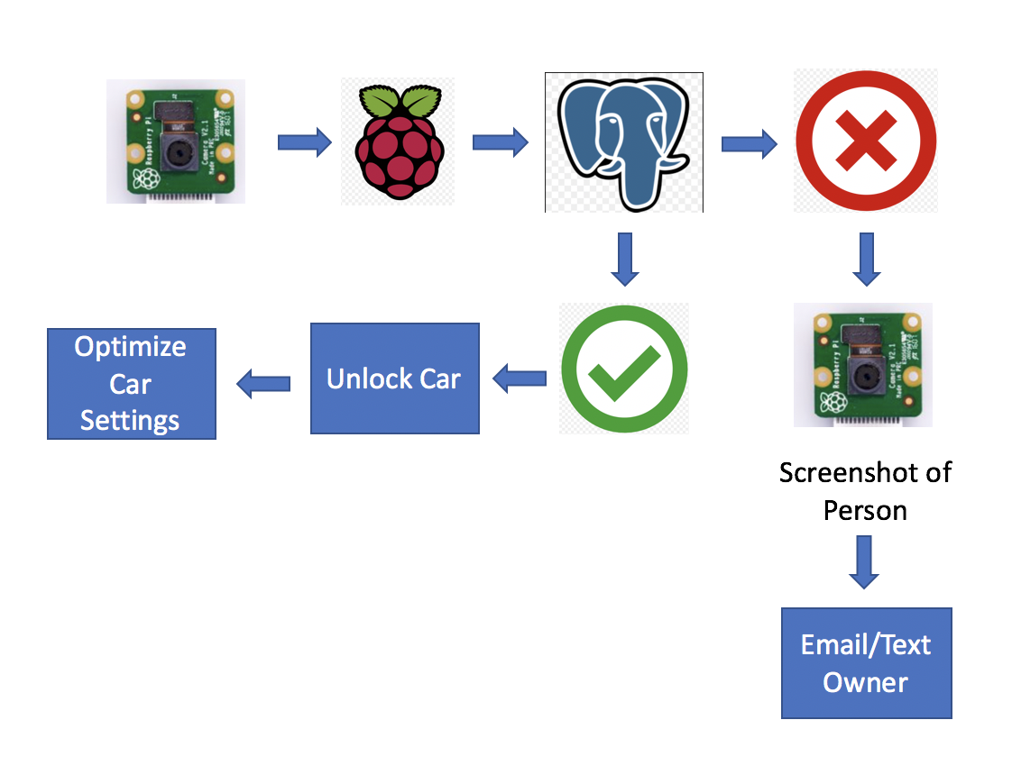
Figure 1: Block Diagram of the Smart Security System

Literature Review
There exists a significant body of works that focuses on the use of biometrics as a form of user authentication and data security.
A similar concept was explored in [1], in which facial recognition was used to unlock a personal assistant platform customized to the person who unlocked it. This system increased the processing capabilities of the system and response time by outsourcing the computations to web servers over using the onboard microcontroller processor.
The authors of [2] used the biometric of fingerprint scanning as their form of user authentication. This concept used PostgreSQL as the database management system, and PHP language for web platform coding.
The work done in [3] was to create a facial recognition system using Haar feature-based cascade classifier. This system boasted high accuracy and fast computational time in comparing biometric samples.

Goals

Proposal for Facial Regognition
This project involves training the program to recognise faces. It will first find a face in a picture (will work way up to video recognition i.e live camera). It will then analyse facial features and take measurements by comparing two or more pictures of the same face to recognise it’s a single person (face landmarks algorithm). Our next task is to get the program to see who it is based on measurement patterns (Neural networks). We will be using as follow:
Suggested libraries -> dlib
Suggested language(s) -> python, C++
Dlib was created by Davis King which Adam Geitgey wrote the face recognition module.
See Open Face https://cmusatyalab.github.io/openface/
See for guidelines https://medium.com/@ageitgey/machine-learning-is-fun-part-4-modern-face-recognition-with-deep-learning-c3cffc121d78
See for code examples https://www.pyimagesearch.com/2018/06/18/face-recognition-with-opencv-python-and-deep-learning/
See for live video feed code examples https://www.pyimagesearch.com/2018/06/25/raspberry-pi-face-recognition/

Picture Recognition
For picture recognition, we will start by making the picture black and white. The lighter pixels will be compared to the darker ones by replacing each pixel with an arrow to show the flow of dark pixels to light. By considering only the gradient of the arrows, that’s how the computer will be able to tell the difference between faces. Each person will have their personal gradients, per say. Once the pixels have been differentiated and the gradient has been detected, the image is converted to a Histogram of Oriented Gradients (HOG) image which clearly shows the major components on the face.

Face Landmark Detection

For face landmark detection, we will be finding the location of the different facial features. Using the algorithm face landmark estimation, specific points are noted about the face, so the face can be detected at different angles.

Face Identity

It turns out, for the computer to really identify a face as fast and as accurate as possible is by training it. (Deep learning). Training the machine to use deep neural networking, the computer compares two pictures of the one face (different pictures) to one different face and is trained to calculate 128 different measurements of each face. The 2 of the same faces should have similar measurements as to one of the two compared to the different face. After comparing results, the computer will tweak the neural net so the 2 pictures are closer to each other rather than 1 of two is close to the other picture.

Supplies
- Raspberry Pi 3 - $30
- Raspberry Pi Camera - $25
- Thumbprint Scanner - $35

References
- R. Novosel, B. Meden, Z. Emersic, V. Struc, P. Peer. “Face recognition with Raspberry Pi for IoT Environments,” International Electrotechnical and Computer Science Conference, 2017.
- L. Arunkumar, A. Arun Raja. “Biometrics Authentication Using Raspberry Pi.” International Journal for Trends in Engineering & Technology, vol. 5.2, 2015.
- O. Nikisins, R. Fuksis, A. Kadikis, M. Greitans. “Face recognition system on Raspberry Pi,” International Conference on Information Processing and Control Engineering, 2015.
IEEE confer
[4] R. A. Shinde, Y. B. Mane. “Advanced Vehicle Monitoring and Tracking System based on Raspberry Pi,” International Conference on Intelligent Systems and Control, 2015.
[5] R. Khan, S. Ahmed, F. Khan, P. Komte, B. Akhtar. “Biometric Scanning Based on Vehicle Ignition System,” International Journal of Engineering Science and Computing, vol. 7, no. 3, 2017.

[6] M. Martin, K. Stefan, F. L’ubor. “Biometrics Authentication of Fingerprint with Using Fingerprint Reader and Microcontroller Arduino,” Telkomnika, vol. 16, no. 2, pp. 755-765, 2018.

[7] S. Syed, M. Jain, P. Dey, N. Ahmed. “Embedded System for Automatic Door Access using Face Recognition Technique and Cloud Based Services,” International Research Journal of Engineering and Technology, vol. 06, no. 06, 2018.

[8] G. Senthilkumar, K. Gopalakrishnan, V. Sathish Kumar. “Embedded Image Capturing System Using Raspberry Pi System,” vol. 3, no. 2, 2014.

[9] H. Khodaskar, S. Mane. “Human Face Detection & Recognition Using Raspberry Pi,” International Conference on Science and Engineering for Sustainable Development, 2017.

[10] Q. Sun, R. Odolinksi, J. Xia, J. Foster, T. Falkmer, H. Lee. “Validating the efficacy of GPS tracking vehicle movement for driving behavior assessment,” Travel and Behavior Society, vol. 6, pp. 32-43, 2017.

[11] j. Balbin, R. Garcia, M. Latina, M. A. S. Allanigue, J. K. Ammen, A. V. Bague, J. Jimenez. “Vehicle Door Latch with Tracking and Alert System using Global Positioning System Technology and IoT Based Hardware Control for Visibility and Security of Assets,” International Conference on Humanoid, Nanotechnology, Information Technology, Communication and Control, Environment and Management, 2017.

templates contain guidance text for

